**SCD Lab 04**

**Name:** Hafsa Salman

**Roll no.** 22K-5161

**Task no. 01**

Code:

//Hafsa Salman  
//22K-5161  
//Task no. 01  
  
import javax.swing.*;  
import java.awt.event.ActionEvent;  
import java.awt.event.ActionListener;  
import java.util.Objects;  
  
public class Task_01 extends JFrame  
{  
 private JPanel Task_01A;  
 private JLabel Name;  
 private JLabel FatherName;  
 private JLabel CNIC;  
 private JLabel PNo;  
 private JLabel Pass1;  
 private JLabel Pass2;  
 private JLabel Gender;  
 private JLabel Nationality;  
 private JLabel Email;  
 private JTextField NameTxt;  
 private JTextField FNameTxt;  
 private JTextField CnicTxt;  
 private JTextField PnoTxt;  
 private JPasswordField Pass1Txt;  
 private JPasswordField Pass2Txt;  
 private JComboBox GenderTxt;  
 private JTextField NationalityTxt;  
 private JTextField EmailTxt;  
 private JButton btn;  
  
 public Task_01()  
 {  
 btn.addActionListener( new ActionListener()  
 {  
 @Override  
 public void actionPerformed(ActionEvent e)  
 {  
 String n = NameTxt.getText();  
 String fn = FNameTxt.getText();  
 String Cnic = CnicTxt.getText();  
 String Pno = PnoTxt.getText();  
  
 char[] p1 = Pass1Txt.getPassword();  
 String Pa1 = new String(p1);  
  
 char[] p2 = Pass2Txt.getPassword();  
 String Pa2 = new String(p2);  
  
 String g = (String) GenderTxt.getSelectedItem();  
  
 String Nation = NationalityTxt.getText();  
 String E = EmailTxt.getText();  
  
 if (Objects.*equals*(n, null))  
 {  
 JOptionPane.*showMessageDialog*(btn, "Name Field is empty!");  
 }  
  
 else if (Objects.*equals*(fn, null))  
 {  
 JOptionPane.*showMessageDialog*(btn, "Father's Name Field is empty!");  
 }  
  
 else if (Objects.*equals*(Cnic, null))  
 {  
 JOptionPane.*showMessageDialog*(btn, "CNIC Field is empty!");  
 }  
  
 else if (Objects.*equals*(Pno, null))  
 {  
 JOptionPane.*showMessageDialog*(btn, "Phone Number Field is empty!");  
 }  
  
 else if (Objects.*equals*(Pa1, null))  
 {  
 JOptionPane.*showMessageDialog*(btn, "Password Field is empty!");  
 }  
  
 else if (Objects.*equals*(Pa2, null))  
 {  
 JOptionPane.*showMessageDialog*(btn, "Re-enter Password Field is empty!");  
 }  
  
 else if (Objects.*equals*(Nation, null))  
 {  
 JOptionPane.*showMessageDialog*(btn, "Nationality field is empty!");  
 }  
  
 else if (Objects.*equals*(g, "--"))  
 {  
 JOptionPane.*showMessageDialog*(btn, "Gender field is empty!");  
 }  
  
 else if (Objects.*equals*(E, null))  
 {  
 JOptionPane.*showMessageDialog*(btn, "Email field is empty!");  
 }  
  
 else if (!Objects.*equals*(Pa1, Pa2))  
 {  
 JOptionPane.*showMessageDialog*(btn, "Password and Re-entered password are not same!");  
 }  
  
 else  
 {  
 new Task_01B(n, fn, Cnic, Pno, g, Nation, E);  
 dispose();  
 }  
 }  
 });  
 }  
  
 public static void main(String[] args)  
 {  
 Task_01 T1 = new Task_01();  
  
 T1.setContentPane(T1.Task_01A);  
 T1.setTitle("Registration Form (22K-5161)");  
 T1.setSize(500, 500);  
 T1.setVisible(true);  
  
 T1.setDefaultCloseOperation(JFrame.*EXIT_ON_CLOSE*);  
 }  
}

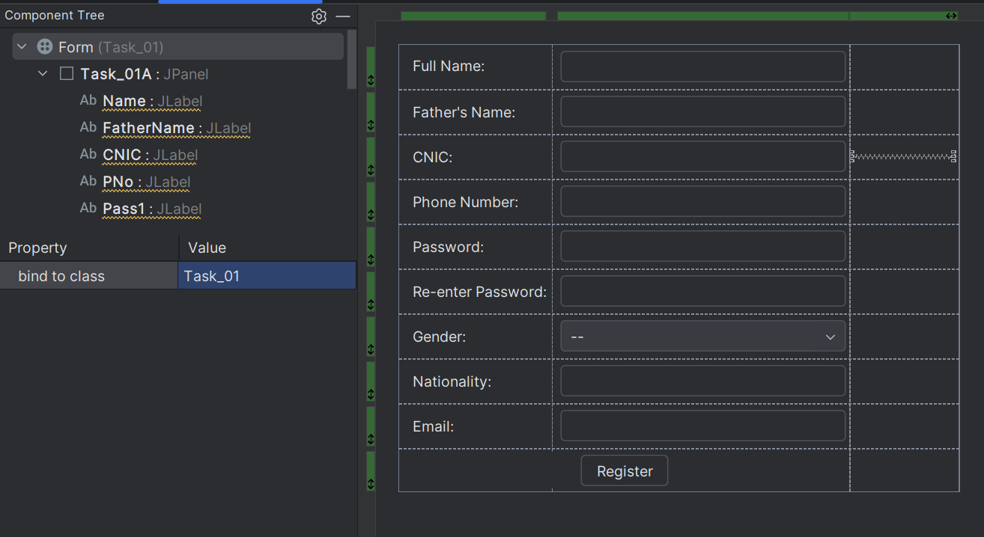

//Hafsa Salman  
//22K-5161  
//Task no. 01  
  
import javax.swing.*;  
import java.awt.event.ActionEvent;  
import java.awt.event.ActionListener;  
  
public class Task_01B extends JFrame  
{  
 private JPanel Task_01B;  
 private JTextArea Meow;  
 private JButton btn;  
  
 public Task_01B(String Name, String Father, String CNIC, String Phone, String Gender, String Nationality, String Email)  
 {  
 setContentPane(Task_01B);  
 setTitle("Registration Form (22K-5161)");  
 setSize(500, 500);  
 setVisible(true);  
  
 setDefaultCloseOperation(JFrame.*EXIT_ON_CLOSE*);  
  
 Meow.setText("Name: " + Name + "\nFather Name: " + Father + "\nCNIC: " + CNIC + "\nPhone No.: " + Phone + "\nGender: " + Gender + "\nNationality: " + Nationality + "\nEmail: " + Email);  
  
  
 btn.addActionListener(new ActionListener()  
 {  
 @Override  
 public void actionPerformed(ActionEvent e)  
 {  
 dispose();  
 }  
 });  
 }  
}

Output:

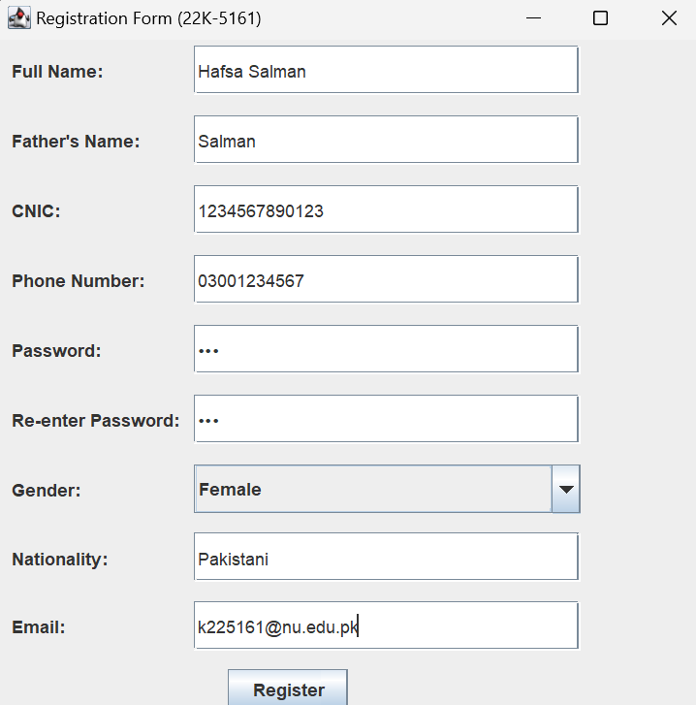

**Task no. 02**

Code:

//Hafsa Salman  
//22K-5161  
//Task no. 02  
  
import javax.swing.*;  
import java.awt.event.ActionEvent;  
import java.awt.event.ActionListener;  
import java.awt.event.KeyAdapter;  
import java.awt.event.KeyEvent;  
  
public class Task_02 extends JFrame  
{  
 private JPanel Task_02;  
 private JLabel Alpha;  
 private JTextField KeyTxt;  
 private JTextArea Well;  
 private JButton Btn;  
  
  
 public Task_02()  
 {  
 KeyTxt.addKeyListener(new KeyAdapter()  
 {  
 @Override  
 public void keyTyped(KeyEvent e)  
 {  
 super.keyTyped(e);  
  
 char ch = e.getKeyChar();  
 int value = (int) ch;  
  
 Well.setText("Typed Alphabet: " + ch + "\nASCII: " + value);  
 }  
 });  
  
 Btn.addActionListener(new ActionListener()  
 {  
 @Override  
 public void actionPerformed(ActionEvent e)  
 {  
 dispose();  
 }  
 });  
 }  
  
 public static void main(String[] args)  
 {  
 Task_02 T2 = new Task_02();  
  
 T2.setContentPane(T2.Task_02);  
 T2.setTitle("ASCII Code (22K-5161)");  
 T2.setSize(300, 300);  
 T2.setLocationRelativeTo(null);  
 T2.setVisible(true);  
  
 T2.setDefaultCloseOperation(JFrame.*EXIT_ON_CLOSE*);  
 }  
}

Output:

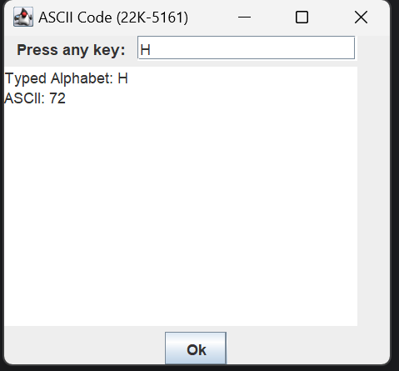

**Task no. 03**

Code:

//Hafsa Salman  
//22K-5161  
//Task no. 03  
  
import javax.swing.*;  
import java.awt.event.ActionEvent;  
import java.awt.event.ActionListener;  
  
public class Task_03 extends JFrame  
{  
 private JPanel Task_03;  
 private JLabel Acc;  
 private JTextField AccTxt;  
 private JPasswordField PassTxt;  
 private JLabel Pass;  
 private JButton Btn;  
  
 public Task_03()  
 {  
 Btn.addActionListener(new ActionListener()  
 {  
 @Override  
 public void actionPerformed(ActionEvent e)  
 {  
 if (AccTxt.getText().equals("123456789") && PassTxt.getText().equals("0123"))  
 {  
 new Task_03B();  
 dispose();   
 }  
  
 else  
 {  
 JOptionPane.*showMessageDialog*(Btn, "Invalid Account No. or Password!");  
 }  
 }  
 });  
 }  
  
 public static void main(String[] args)  
 {  
 Task_03 T3 = new Task_03();  
 T3.setContentPane(T3.Task_03);  
 T3.setTitle("ATM (22K-5161)");  
 T3.setSize(500, 500);  
 T3.setVisible(true);  
  
 T3.setDefaultCloseOperation(JFrame.*EXIT_ON_CLOSE*);  
 }  
}

//Hafsa Salman  
//22K-5161  
//Task no. 03  
  
import javax.swing.*;  
import java.awt.event.ActionEvent;  
import java.awt.event.ActionListener;  
  
public class Task_03B extends JFrame  
{  
 private JLabel Whe;  
 private JButton btn1;  
 private JButton btn2;  
 private JButton btn3;  
 private JButton btn4;  
 private JPanel Task_03B;  
  
 final static int *amount* = 5000;  
  
 public Task_03B()  
 {  
 setContentPane(Task_03B);  
 setTitle("ATM (22K-5161)");  
 setSize(500, 500);  
 setVisible(true);  
  
 setDefaultCloseOperation(JFrame.*EXIT_ON_CLOSE*);  
  
 //Amount Balance  
 btn1.addActionListener(new ActionListener()  
 {  
 @Override  
 public void actionPerformed(ActionEvent e)  
 {  
 JOptionPane.*showMessageDialog*(btn1, "Current Balance: " + *amount*);  
 }  
 });  
  
 //Deposit Money  
 btn2.addActionListener(new ActionListener()  
 {  
 @Override  
 public void actionPerformed(ActionEvent e)  
 {  
 new Task_03C(*amount*);  
 dispose();  
 }  
 });  
  
 //Withdraw Money  
 btn3.addActionListener(new ActionListener()  
 {  
 @Override  
 public void actionPerformed(ActionEvent e)  
 {  
 new Task_03D(*amount*);  
 dispose();  
 }  
 });  
  
 //Exit  
 btn4.addActionListener(new ActionListener()  
 {  
 @Override  
 public void actionPerformed(ActionEvent e)  
 {  
 JOptionPane.*showMessageDialog*(btn4, "Exited Successfully");  
 dispose();  
 }  
 });  
 }  
}

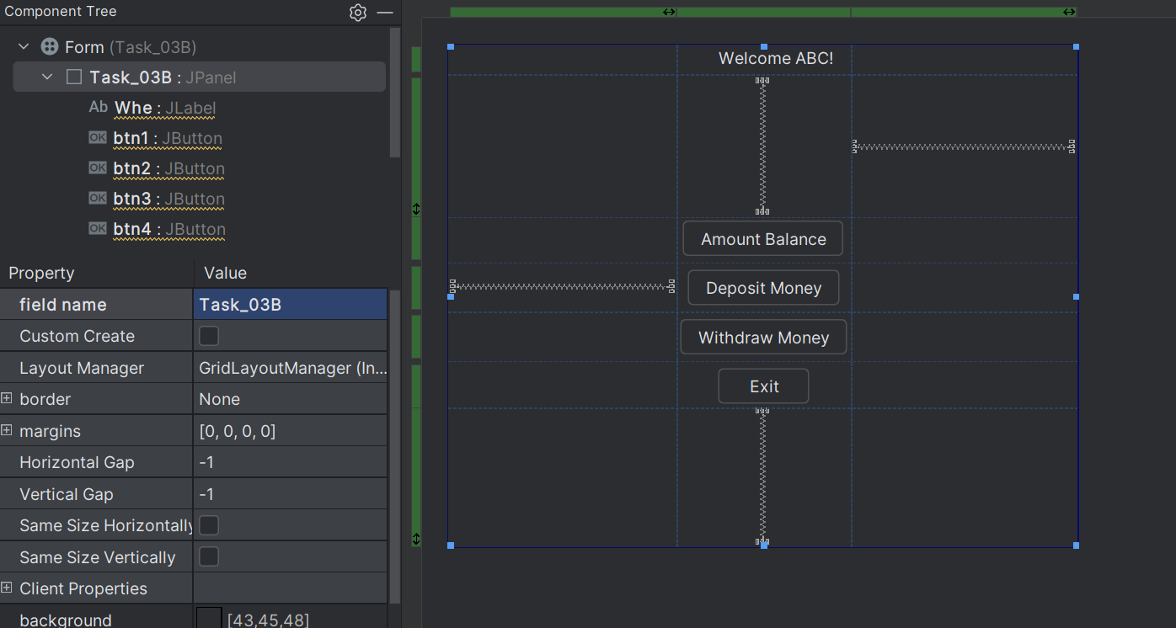

//Hafsa Salman  
//22K-5161  
//Task no. 03  
  
import javax.swing.*;  
import java.awt.event.ActionEvent;  
import java.awt.event.ActionListener;  
  
public class Task_03C extends JFrame  
{  
 private JPanel Task_03C;  
 private JLabel Deposit;  
 private JTextField Dep;  
 private JButton btn;  
  
 public Task_03C(int initialAmount)  
 {  
 setContentPane(Task_03C);  
 setTitle("ATM (22K-5161)");  
 setSize(500, 500);  
 setVisible(true);  
  
 setDefaultCloseOperation(JFrame.*EXIT_ON_CLOSE*);  
  
 final int[] amount = {initialAmount};  
  
 btn.addActionListener(new ActionListener()  
 {  
 @Override  
 public void actionPerformed(ActionEvent e)  
 {  
 int am = Integer.*parseInt*(Dep.getText());  
  
 if (am < 0)  
 {  
 JOptionPane.*showMessageDialog*(btn, "Please enter valid amount!");  
 }  
 else  
 {  
 amount[0] = amount[0] + am;  
  
 JOptionPane.*showMessageDialog*(btn, "Deposit successful!" + "\nCurrent balance: " + amount[0]);  
 dispose();  
 }  
 }  
 });  
 }  
}

//Hafsa Salman  
//22K-5161  
//Task no. 03  
  
import javax.swing.*;  
import java.awt.event.ActionEvent;  
import java.awt.event.ActionListener;  
  
public class Task_03D extends JFrame  
{  
 private JPanel Task_03D;  
 private JLabel Withdraw;  
 private JTextField WDTxt;  
 private JButton btn;  
  
 public Task_03D(int amount)  
 {  
 setContentPane(Task_03D);  
 setTitle("ATM (22K-5161)");  
 setSize(500, 500);  
 setVisible(true);  
  
 setDefaultCloseOperation(JFrame.*EXIT_ON_CLOSE*);  
  
 final int[] Amount = {amount};  
  
 btn.addActionListener(new ActionListener()  
 {  
 @Override  
 public void actionPerformed(ActionEvent e)  
 {  
 int am = Integer.*parseInt*(WDTxt.getText());  
  
 if (am < 0)  
 {  
 JOptionPane.*showMessageDialog*(btn, "Please enter valid amount!");  
 }  
 else  
 {  
 Amount[0] = Amount[0] - am;  
  
 JOptionPane.*showMessageDialog*(btn, "Withdrawn successful!" + "\nCurrent balance: " + Amount[0]);  
 dispose();  
 }  
 }  
 });  
 }  
}

Output:

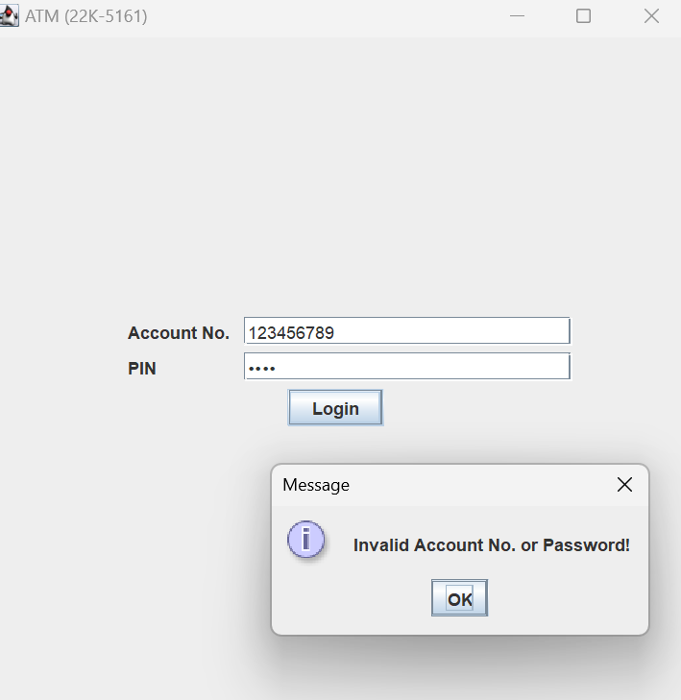

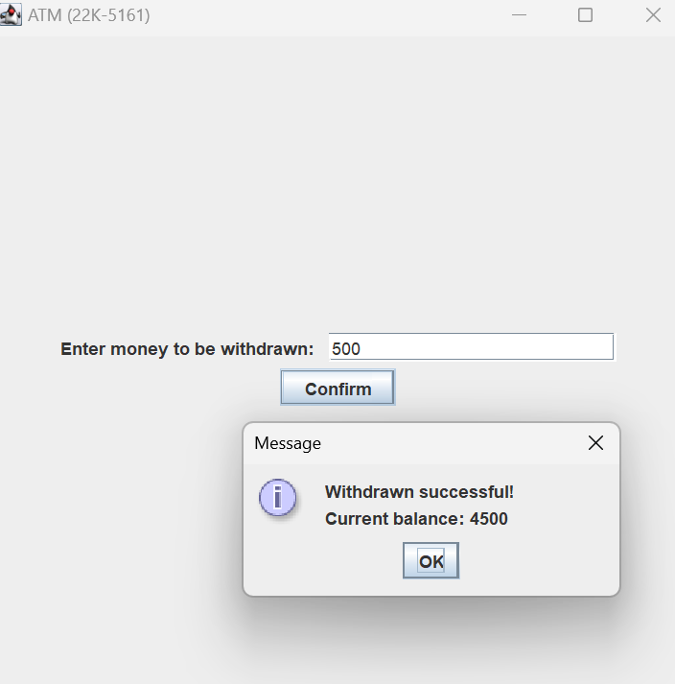

**Task no. 04**

Code:

//Hafsa Salman  
//22K-5161  
//Task no. 04  
  
import javax.swing.*;  
import java.awt.event.ActionEvent;  
import java.awt.event.ActionListener;  
import java.util.ArrayList;  
  
public class Task_04 extends JFrame  
{  
 private JPanel Task_04;  
 private JLabel SDetails;  
 private JLabel Name;  
 private JTextField NameTxt;  
 private JLabel Roll;  
 private JTextField RollTxt;  
 private JLabel Class;  
 private JTextField ClassTxt;  
 private JLabel Grade;  
 private JLabel Course1;  
 private JLabel Calculus_Grade;  
 private JTextField textField1;  
 private JTextField textField2;  
 private JLabel Calculus_CrHr;  
 private JLabel English;  
 private JLabel English_Grade;  
 private JTextField textField3;  
 private JTextField textField4;  
 private JLabel English_CrHr;  
 private JLabel PF;  
 private JTextField textField5;  
 private JLabel PF_CrHr;  
 private JLabel PF_Grade;  
 private JTextField textField6;  
 private JButton btn1;  
 private JButton btn2;  
 private JButton btn3;  
 private JLabel SGPAvalue;  
 private JLabel SGPA;  
  
  
 public Task_04()  
 {  
 btn1.addActionListener(new ActionListener()  
 {  
 @Override  
 public void actionPerformed(ActionEvent e)  
 {  
 if (isInputValid())  
 {  
 ArrayList<Double> grades = new ArrayList<>();  
 grades.add(Double.*parseDouble*(textField1.getText()));  
 grades.add(Double.*parseDouble*(textField3.getText()));  
 grades.add(Double.*parseDouble*(textField5.getText()));  
 ArrayList<Integer> credits = new ArrayList<>();  
 credits.add(Integer.*parseInt*(textField2.getText()));  
 credits.add(Integer.*parseInt*(textField4.getText()));  
 credits.add(Integer.*parseInt*(textField6.getText()));  
  
 double sgpa = calculateSGPA(grades, credits);  
 String remark = getPerformanceRemark(sgpa);  
  
 SGPAvalue.setText(Double.*toString*(sgpa));  
 }  
  
 else  
 {  
 JOptionPane.*showMessageDialog*(null, "Invalid Input!");  
 }  
 }  
 });  
  
 btn2.addActionListener(new ActionListener()  
 {  
 @Override  
 public void actionPerformed(ActionEvent e)  
 {  
 if (isInputValid())  
 {  
 ArrayList<Double> grades = new ArrayList<>();  
 grades.add(Double.*parseDouble*(textField1.getText()));  
 grades.add(Double.*parseDouble*(textField3.getText()));  
 grades.add(Double.*parseDouble*(textField5.getText()));  
 ArrayList<Integer> credits = new ArrayList<>();  
 credits.add(Integer.*parseInt*(textField2.getText()));  
 credits.add(Integer.*parseInt*(textField4.getText()));  
 credits.add(Integer.*parseInt*(textField6.getText()));  
  
 double sgpa = calculateSGPA(grades, credits);  
 String remark = getPerformanceRemark(sgpa);  
  
 JOptionPane.*showMessageDialog*(null, "Calculus: \nGrade: " + textField1.getText() + "\nCredit hrs: " + textField2.getText() + "\nEnglish: \nGrade: " + textField3.getText() + "\nCredit hrs: " + textField4.getText() + "\nProgramming Fundamentals: \nGrade: " + textField5.getText() + "\nCredit hrs: " + textField6.getText() + "\nSGPA: " + sgpa + "\nRemarks: " + remark);  
 }  
  
 else  
 {  
 JOptionPane.*showMessageDialog*(null, "Invalid input!");  
 }  
  
 }  
 });  
 btn3.addActionListener(new ActionListener()  
 {  
 @Override  
 public void actionPerformed(ActionEvent e)  
 {  
 NameTxt.setText("");  
 RollTxt.setText("");  
 ClassTxt.setText("");  
 textField1.setText("");  
 textField2.setText("");  
 textField3.setText("");  
 textField4.setText("");  
 textField5.setText("");  
 textField6.setText("");  
 SGPAvalue.setText("");  
 }  
 });  
 }  
  
 private double calculateSGPA (ArrayList<Double> grades, ArrayList<Integer> credits)  
 {  
 double totalPoints = 0;  
 int totalCredits = 0;  
  
 for (int i = 0; i < grades.size(); i++)  
 {  
 totalPoints += grades.get(i) * credits.get(i);  
 totalCredits += credits.get(i);  
 }  
  
 return totalPoints / totalCredits;  
 }  
  
 private String getPerformanceRemark(double sgpa)  
 {  
 if (sgpa >= 9)  
 {  
 return "Excellent";  
 }  
  
 else if (sgpa >= 3.5)  
 {  
 return "Very Good";  
 }  
  
 else if (sgpa >= 3)  
 {  
 return "Good";  
 }  
  
 else if (sgpa >= 2.5)  
 {  
 return "Satisfactory";  
 }  
  
 else  
 {  
 return "Needs Improvement";  
 }  
 }  
 private boolean isInputValid()  
 {  
 try  
 {  
 if (textField1.getText().isEmpty() || textField2.getText().isEmpty() || textField3.getText().isEmpty() || textField4.getText().isEmpty() || textField5.getText().isEmpty() || textField6.getText().isEmpty())  
 {  
 return false;  
 }  
  
 Double.*parseDouble*(textField1.getText());  
 Double.*parseDouble*(textField3.getText());  
 Double.*parseDouble*(textField5.getText());  
 Integer.*parseInt*(textField2.getText());  
 Integer.*parseInt*(textField4.getText());  
 Integer.*parseInt*(textField6.getText());  
  
 }  
  
 catch (NumberFormatException ex)  
 {  
 return false;  
 }  
  
 return true;  
 }  
  
 public static void main(String[] args)  
 {  
 Task_04 T4 = new Task_04();  
  
 T4.setContentPane(T4.Task_04);  
 T4.setTitle("SGPA (22K-5161)");  
 T4.setSize(500, 500);  
 T4.setVisible(true);  
  
 T4.setDefaultCloseOperation(JFrame.*EXIT_ON_CLOSE*);  
 }  
}

Output:

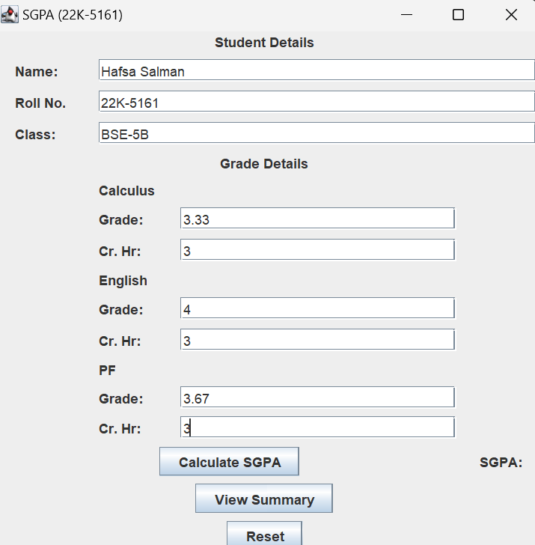

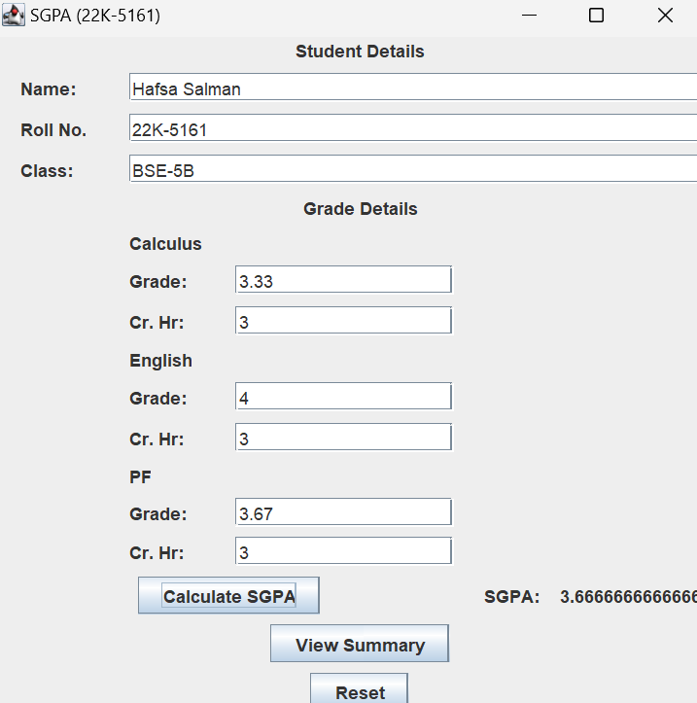

//After clicking reset button

**Task no. 05**

Code:

//Hafsa Salman  
//22K-5161  
//Task no. 05  
  
import javax.swing.*;  
import java.awt.event.ActionEvent;  
import java.awt.event.ActionListener;  
import java.awt.event.KeyAdapter;  
import java.awt.event.KeyEvent;  
  
public class Task_05 extends JFrame  
{  
 private JLabel Txt;  
 private JTextArea TxtArea;  
 private JButton btn;  
 private JPanel Task_05;  
 private JComboBox comboBox1;  
 private JTextArea textArea1;  
  
 public Task_05()  
 {  
 TxtArea.addKeyListener(new KeyAdapter()  
 {  
 @Override  
 public void keyReleased(KeyEvent e)  
 {  
 String Input = TxtArea.getText();  
 Transformation (Input);  
 }  
 });  
  
 btn.addActionListener(new ActionListener()  
 {  
 @Override  
 public void actionPerformed(ActionEvent e)  
 {  
 String Input = TxtArea.getText();  
 Transformation (Input);  
 }  
 });  
 }  
  
 public void Transformation (String Input)  
 {  
 if (Input.isEmpty())  
 {  
 JOptionPane.*showMessageDialog* (null, "Please enter a text to transformation");  
 }  
  
 String select = (String) comboBox1.getSelectedItem();  
 String meow;  
  
 if (select.equals("Uppercase"))  
 {  
 meow = Input.toUpperCase();  
 textArea1.setText(meow);  
 }  
  
 else if (select.equals("Reverse"))  
 {  
 meow = new StringBuilder(Input).reverse().toString();  
 textArea1.setText(meow);  
 }  
  
 else if (select.equals("Underscores"))  
 {  
 meow = Input.replace(" ", "_");  
 textArea1.setText(meow);  
 }  
 }  
  
 public static void main(String[] args)  
 {  
 Task_05 T5 = new Task_05();  
  
 T5.setContentPane(T5.Task_05);  
 T5.setTitle("Transformation of Text (22K-5161)");  
 T5.setSize(500, 500);  
 T5.setVisible(true);  
  
 T5.setDefaultCloseOperation(JFrame.*EXIT_ON_CLOSE*);  
 }  
}

Output:



